Rent Reveal
Anonymous Rental Review Platform — Design Document
Alex Perkins & Tom Howes | CS4550 Web Development | Northeastern University

Project Description
Rent Reveal is a full-stack web application where renters can anonymously submit and browse reviews about properties they have lived in. Unlike listing platforms curated by landlords, Rent Reveal centers entirely on tenant experiences — covering management quality, safety, noise, cleanliness, and overall satisfaction. The goal is to give future renters honest, ground-level insight before signing a lease.

User Personas

Rachel — Apartment Seeker
Rachel is searching for a new apartment and wants to know what it actually feels like to live in a building before committing to a tour. She needs fast address-based search, clear per-category ratings, and honest tenant feedback.

Emilie — Former Tenant
Emilie just moved out of an apartment with a slow landlord and recurring safety issues. She wants a quick, anonymous way to warn future renters — no account required, no name attached.

User Stories
- As a former tenant, I want to submit an anonymous review so that I can help future renters make a more informed decision.
- As an apartment seeker, I want to search by address so that I can find reviews for a specific building I am considering.
- As an apartment seeker, I want ratings broken down by category — management, safety, noise, cleanliness — so I can evaluate what matters most to me.
- As an apartment seeker, I want to see properties on a map with color-coded ratings so I can spot well-rated buildings in a neighborhood at a glance.
- As a former tenant, I want to edit or delete my review so that I can correct any mistakes.

MongoDB Collections

Properties Collection
Field | Description
_id | Auto-generated primary key
location | address, city, state, zip, lat, lng
propertyType | apartment, condo, house, studio, townhouse
averageRatings | overall, management, safety, noise, cleanliness (1-5)
reviewCount | Total reviews submitted
createdAt | Timestamp

Reviews Collection
Field | Description
_id | Auto-generated primary key
propertyId | Reference to parent property
ratings | overall, management, safety, noise, cleanliness (1-5)
comments | Free-text tenant comment
createdAt | Timestamp

CRUD Operations

Properties
- Create: Add a new property when submitting a review for an unlisted address
- Read: Browse, search, and view properties with aggregated ratings
- Update: Edit property details; averageRatings auto-recalculated on review changes
- Delete: Remove a property and all associated reviews

Reviews
- Create: Submit an anonymous review with five rating categories and a comment
- Read: View all reviews for a property sorted by most recent
- Update: Edit an existing review comment inline
- Delete: Remove a review, triggering automatic recalculation of property averages

Design Mockups

Home Page — Map View
Split layout with search sidebar and interactive Google Maps view. Properties are marked with color-coded pins: green (4.0+), orange (3.0-3.9), red (below 3.0).
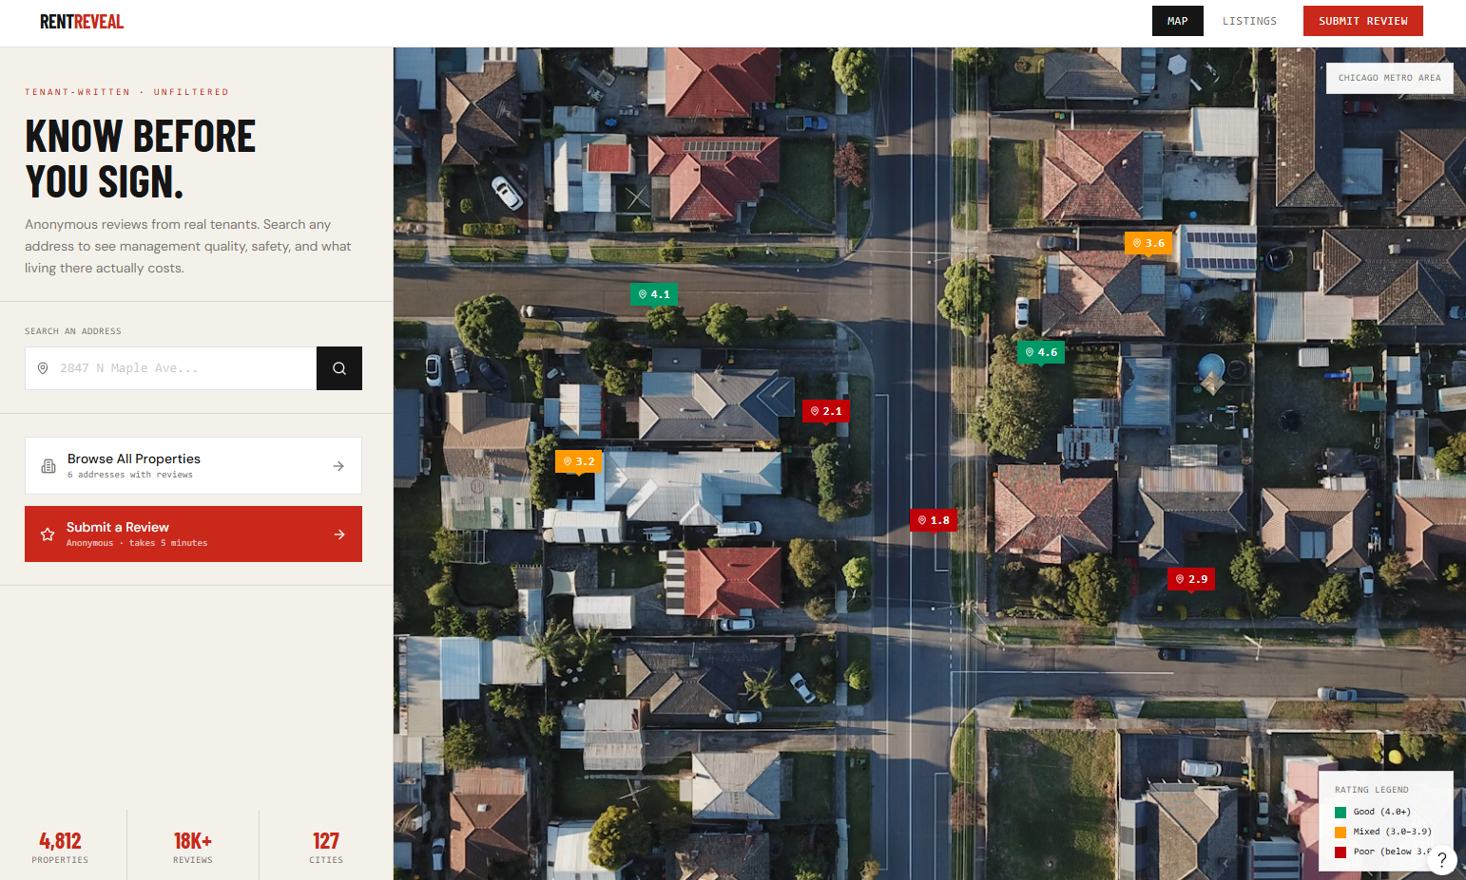

Property Listings Page
Ranked list of properties with summary ratings and per-category breakdown. Sortable by top rated, lowest rated, or most reviewed.
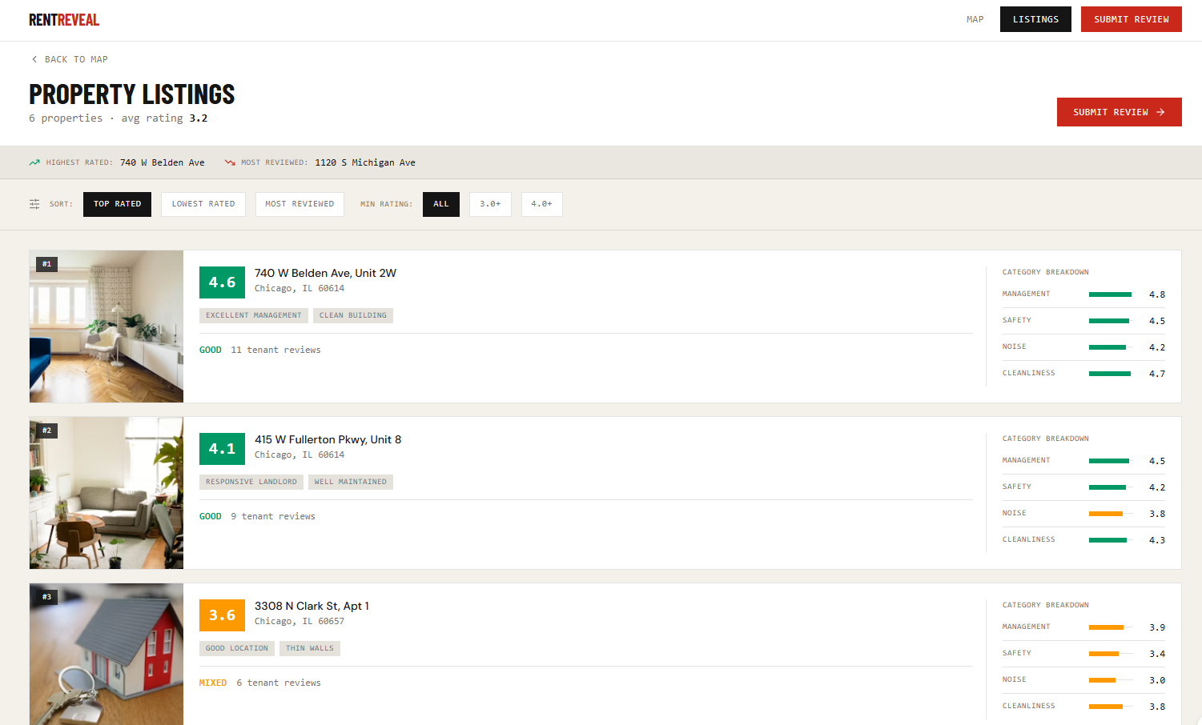

Review Submission Form
Two-step flow: confirm the property exists, then rate across five categories with a written comment. No account required.
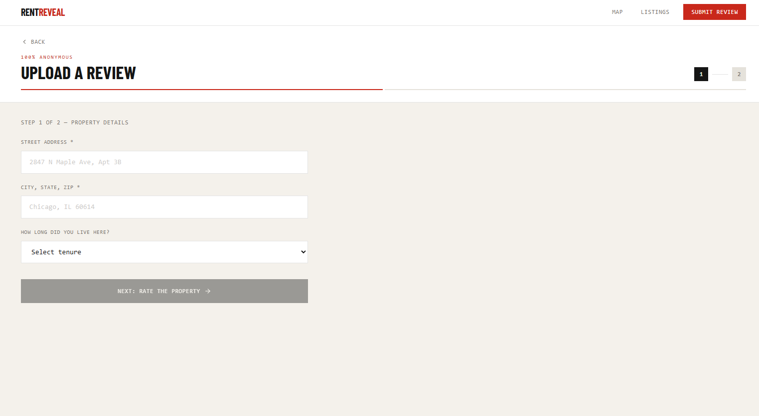

Generative AI Usage
This project made use of generative AI tools in the following ways:

- Claude Sonnet 4.6 (Anthropic) was used to help format and flesh out this design document and the project README, based on our original project proposal and content.
- Figma was used to create the design mockups shown above.

All application code, architectural decisions, and implementation were written by the team.

